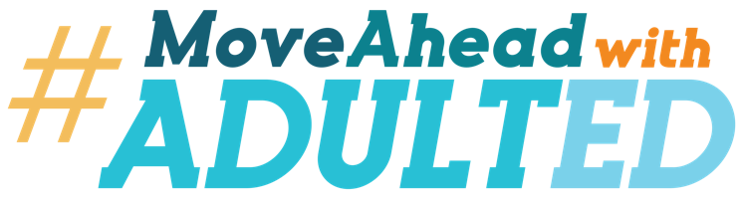
[Insert your logo here]

FOR IMMEDIATE RELEASE
[insert date here]
[insert contact information here]
[YOUR ORGANIZATION NAME] JOINS #MOVE AHEAD WITH ADULT ED CAMPAIGN TO HIGHLIGHT OPPORTUNITIES FOR ADULT LEARNERS
Adult Education supports local adult learners and employers with 2025 workforce challenges

[Insert city, state] – [Insert name of your organization] announces its local efforts to support the national #MoveAheadWithAdultEd campaign through its adult education programs and services. Adult learning refers to the education and training pursued by mature learners (usually college age or older) where they gain knowledge, competence, and skills, which are relevant to the learner and their immediate application. The National Student Clearinghouse reported more than 36 million adults in the United States who have some college experience but no earned credential represented a significant portion of the "adult learner" population in 2024.

This potential workforce talent pool is critical to addressing the massive skills gaps that the reported 87% of companies face this year. A Forbes survey indicated that executives estimated that nearly half (49%) of their employees’ skills will be irrelevant in 2025. Additionally, 47% believed their employees are unprepared for the future. This underscores the urgent need for targeted efforts in upskilling, reskilling, and aligning training with industry demands, all key components of the adult education system’s mission.

To be competitive in this market, employers have increasingly shifted their focus from traditional credentials, like degrees, to skills-based hiring. This shift allows for a more diverse talent pool and gives candidates without degrees a chance to prove their capabilities through relevant skills.

“Adult education provides on-ramps to build skills that lead to better jobs,” said [insert name and title of local leader]. “With adult education, the infrastructure is in place to reskill and upskill Americans to get them on career pathways and support employers with the workforce talent they need to compete.”

The national campaign partners Coalition on Adult Basic Education and the National Association of State Directors of Adult Education created the #MoveAheadWithAdultEd campaign to inform adult learners about the many options adult education offers to build skills and a better life. “Our local adult education programs are part of the larger national adult education system that builds strength in our local economy and community,” continued [insert name and title of local leader].

In [insert your state/region], [insert # for your region] people are enrolled in adult education programs. Among them is [insert name of a learner who increased their skill set & got a good-paying job with a local employer]
[Add copy to expand on the student’s situation, including information about their previous situation, how they found out about adult education, what their goal is now that they are enrolled and how they feel it is changing their life. You can also include information about employers who have benefitted from your services.]

For more information about [insert your organization’s name] and its adult education offerings, go to [insert web address].

###
[Insert organization’s information/byline]

